**Ansible installation on ubuntu**

--- **Reference** - <https://docs.ansible.com/ansible/2.9/installation_guide/intro_installation.html#installing-ansible-on-ubuntu>

--- sudo apt update

--- sudo apt install software-properties-common

--- sudo apt-add-repository --yes --update ppa:ansible/ansible

--- sudo apt install ansible

**# Check the version of ansible**

---- ansible --version

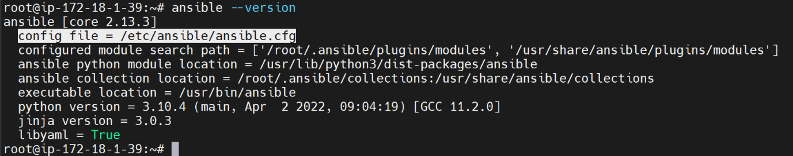

--- **important** – the default ansible config file location.

**# Cat the config file.**

--- cat /etc/ansible/ansible.cfg

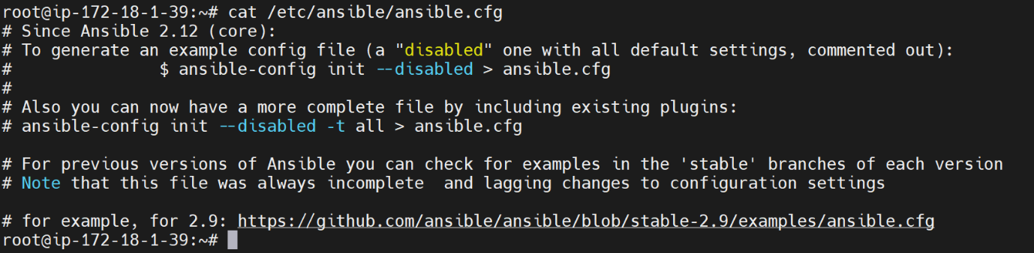

**Create config file in current location**

**# Create a config**

--- ansible-config init --disabled -t all > ansible.cfg

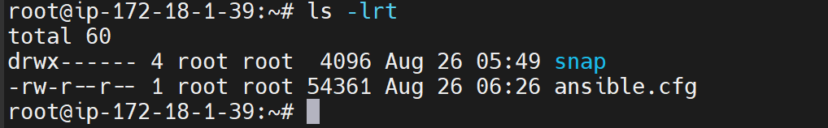

--- **note** – it created ansible.cfg file in current user location.

--- **important** – if you cat this file then all the default options will be there.

**# If you want ansible to write its configuration the above configuration file then execute below command**

--- ansible-config init --disabled -t all > /root/ansible.cfg

**# Check whether the ansible is writing the configuration to above ansible.cfg**

--- ansible --version

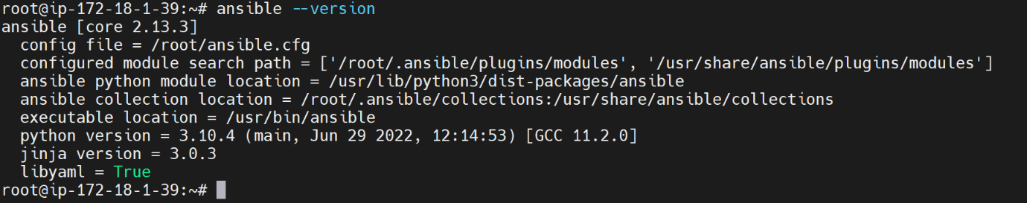

--- host_key_checking=False – Determine if SSH should check hots keys.